**MINI PROJECT REPORT**

**on Sneaker Hub**

**Submitted as partial fulfilment of**

# MASTER OF COMPUTER APPLICATION DEGREE

**SESSION 2023-24**

**By**

**Yash Chauhan 2200320140197**

## Under the guidance of

**( M r . A s h e es h P a n d e y )**

**(Assistant Professor)**

**ABES ENGINEERING COLLEGE, GHAZIABAD (032)**



**AFFILIATED TO**

**Dr. A.P.J ABDUL KALAM TECHNICAL UNIVERSITY, UTTAR PRADESH LUCKNOW**

Ref. No. :- ABES/ MCA /2023-24/001 Date:

**TO WHOMSOEVER IT MAY CONCERN**

This is to certify that Mini Project bearing title "Sneaker Hub" is a bonafide record of project work done successfully by Mr. Yash Chauhan (2200320140197) of MCA-III semester under my supervision in partial fulfillment for the award of the degree in Master of computer Application from Dr. A.P.J. Abdul Kalam Technical University, Lucknow during the session 2023-24.

Mr. Asheesh Pandey Assistant Professor

Prof. (Dr.) Devendra Kumar

Internal Guide Head of Department

MCA Dept. MCA Dept

**STUDENT DECLARATION**

I hereby declare that the work being presented in this report entitled “**Sneaker Hub”** is an authentic record of my own work carried out under the supervision of **“Mr. Asheesh Pandey”.**

**Date: Signature of Student**

**Yash Chauhan**

This is to certify that the above statement made by the candidate is correct to the best of my knowledge.

**Signature of HOD Signature of Internal Prof. (Dr.) Devendra Kumar Mr. Asheesh Pandey HOD-MCA Assistant Professor**

**Date:**

**ACKNOWLEDGEMENT**

Any software project is not a work of an individual. It combines effort, ideas, suggestions, reviews, and hard work. I thank all who initiated and helped us to complete my project. One of the most pleasing aspects of collecting the necessary information and compiling it is the opportunity to thank those who have actively contributed to it.

I would like to thank my guide for his/her guidance and cooperation render for following me to undergo training under his/her guidance; I am also thanks to all the other college staff who helped me despite their busy schedule.

My special thanks to **Mr. Asheesh Pandey, Assistant Professor** for his active support, affectionate, guidance and constant encouragement.

I am highly indebted to **Prof. (Dr.) Devendra Kumar (HOD-MCA)** for his continuous effort in building a good infrastructure and developing a professional attitude within ourselves during the academic period of MCA (Master of Computer Application).

**Signature of Student Yash Chauhan 2200320140197**

**MCA-III Semester**

**ABSTRACT**

Today most of the colleges are using either manual system for registration in college event’s activity or they have lots of paperwork and they are using desktop, spread sheet like MS Excel application to manage data in soft copy about student’s registration. In this proposed Online Events Registration System, it will run on a server and the user can handle whole the registration activities. It has facilities to generate several types of reports (like pdf, excel) which are required by the management during event organizing.

This application maintains the centralized database so that any changes done at a location reflects immediately. This is an online tool so more than one user can login into the system and use the tool simultaneously.

The aim of this application is to reduce the manual effort needed to manage transactions and historical data used in various god owns. Also, this application provides an interface to users to view the details about events.

**TABLE OF CONTENT**

|  |  |  |  |  |
| --- | --- | --- | --- | --- |
| **Sr.**  **No.** | **Content** | | | **Page No.** |
| 1. | Introduction | | | 1 |
|  | 1.1 | Problem Statement | | 1 |
| 2. |  | Objective | | 2 |
|  |  |  | |  |
| 3. | Feasibility Study | | | 3 |
|  | 3.1 | | Technical Feasibility   * Model Availability * Technology Stack * Hardware Requirements | 3 |
|  | 3.2 | | Operational Feasibility   * Ease of Integration * User-friendly Interface * Scalability | 3 |
|  | 3.3 | | Economic Feasibility   * Cost of Estimation | 3 |
|  |  | |  |  |
| 4. | Requirements Analysis | | | 4 |
|  | 4.1 | Functional Requirements | | 4 |
|  | 4.2 | Non-Functional Requirements | | 4 |
|  | 4.3 | Technologies Used   * Frontend * Backend | | 4 |
| 5. | Design | | | 6 |
|  |  |  | |  |
|  | 5.1 | ER-Diagram | | 6 |
|  | 5.2 | Data Flow Diagram (Zero Level DFD) | | 7 |
|  | 5.3 | Data Flow Diagram (Two Level DFD) | | 8 |
|  | 5.4 | Data Flow Diagram (Three Level DFD) | | 9 |
|  | 5.5  5.6 | Use Case Diagram Class Diagram | | 10  11 |

|  |  |  |  |  |
| --- | --- | --- | --- | --- |
|  |  |  | |  |
|  | 5.7 Deployment Diagram | | | 12 |
| 6. |  | | Modules Screenshot | 13-20 |
| 7. | Coding Phase | | | 21-52 |
| 8. | Timeline of Project | | | 53 |
| 9. | Gantt Chart | | | 54 |

|  |  |  |
| --- | --- | --- |
| 10. | Benefits | 55 |
| 11. | Scope | 55 |
| 12. | Conclusion | 56 |
| 13. | References | 57 |

**LIST OF FIGURES**

|  |  |  |
| --- | --- | --- |
| **S. No.** | **Topic** | **Page No.** |
|  |  |  |
| Figure-1 | ER-Diagram | 6 |
| Figure-2 | 0,1,2 level DFD | 7,8,9 |
| Figure-3 | Use Case Diagram | 10 |
| Figure-4 | Class Diagram | 11 |
| Figure-5 | Deployment Diagram | 12 |

**LIST OF TABLES**

|  |  |  |
| --- | --- | --- |
| **S. No.** | **Topics** | **Page No.** |
| Table-1 | Timeline of Project | 55 |
| Table -2 | Gantt Chart | 56 |

# SNEAKER HUB

1. **INTRODUCTION**

"Online Clothing Store" was created to solve the problems existing in the manual. This so ftware support is aimed at alleviating problems experienced by existing systems in certain situations. In addition, the system is designed according to the specific needs of the compa ny so that it can do business efficiently and effectively. Reduce requests to avoid errors w hen entering information. It also gives error messages when no data is entered. Users do n ot need to know how to use the system. So all this proves that it is user friendly.

As we mentioned above, the online shoe store can be errorfree, safe, reliable and fast. It h elps users focus on their other activities rather than focusing on data storage. Therefore, it will help organizations use resources better. Order, customer, payment, shopping cart, billi ng information. Every online shoe store has different customer needs, so we create a perso nnel management system that suits your management needs. Its purpose is to assist with st rategic planning and help ensure that your organization is equipped with the necessary and expanded information for your future goals. Additionally, for busy supervisors constantly on the go, our system has remote access features that allow you to manage your staff fro m anywhere. These systems will ultimately allow you to better manage your resources.

## Problem Statement

Many sneaker enthusiasts struggle to find a centralized platform that offers comprehensive information, latest updates, and a vibrant community around sneakers. Existing websites often lack user-friendly interfaces, fail to cater to diverse preferences, and lack features that enhance the overall sneaker culture experience.

1. **OBJECTIVE**

▣The main objective to design the project is to facilitate the user with categorized shopping in less and efficient manner

▣This website is easy to use and can be used to find the wonderful and latest options in bags, shoes and pullover, hoodies and etc.

▣It's also convenient to use in a way that it has separate section for adding product and getting the details for it.

1. **FEASIBILITY STUDY:**

Feasibility Study for Sneaker Hub:

## Technical Feasibility:

* + - **Model Availability:**

The Sneaker Hub website offers a comprehensive model availability feature, allowing users to easily search for and track the availability of their favorite sneaker models.

## Technology Stack:

Html, Css3, JavaScript and JSON use for databases which are widely supported in the computer vision and deep learning communities.

## Hardware Requirements:

Can run on standard hardware, including laptops, desktops, and edge devices, without requiring high-end specifications.

**3.2 Operational Feasibility:**

## Ease of Integration:

The ease of integration for the Sneaker Hub website would largely depend on its architecture, design, and the availability of APIs from third-party services such as retailers and marketplaces.

## User-Friendly Interface:

Creating a user-friendly interface for the Sneaker Hub website involves several key considerations to enhance the overall user experience.

## Scalability:

Ensuring the scalability of the project is crucial to accommodate growth in user traffic, content volume, and feature complexity over time.

## Economic Feasibility:

* + - **Cost of Implementation:**

The project utilizes open-source libraries and pre-trained models, minimizing development costs.

1. **REQUIREMENT ANALYSIS**
   1. **Functional Requirements:**

▣User login- this feature is used by the user to login into system

1. User id and password will be generated
2. Only registered user will be able to access the website
3. Only registered user will be able to checkout with the purchase they have made

## Non-functional Requirements:

* 1. Efficiency
  2. Reliability requirement
  3. Usability requirement
  4. Implementation requirement
  5. Delivery requirement

## Technologies Used:

The technology stack used in the Sneaker Hub project could include a combination of frontend, backend, and infrastructure technologies tailored to meet the specific requirements of the website. Here's a possible technology stack

* + - **Frontend:**

**Html, CSS, JavaScript:**

* + - For building the basic structure, styling, and interactivity of the website.
    - Frontend JavaScript frameworks for building dynamic and responsive user interfaces.
    - **Backend:**

**JavaScript:**

* + - A JavaScript runtime environment used for building scalable sever-side applications.

**JSON:**

* + - NoSQL or relational databases for storing user data, product information, and other application data.
    - For securely transmitting information between parties and implementing user authentication and authorization.

This technology stack is just a suggestion and can be a customized based on factors such as project requirements, team expertise, scalability needs, and budget constraints.

1. **DESIGN**

**ER Diagram**

**(Entity Relationship Diagram)**

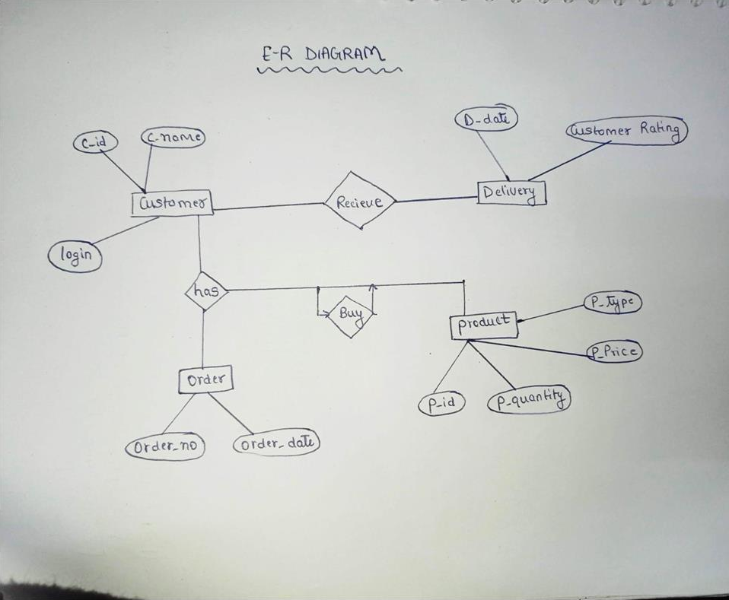

* 1. **DFD 0 LEVEL DIAGRAM**

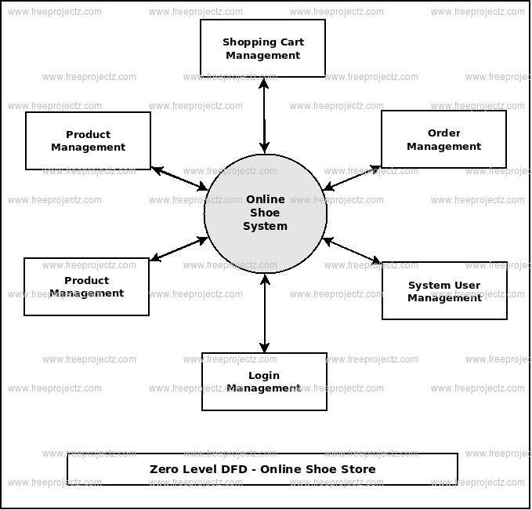

* 1. **DFD 1 LEVEL DIAGRAM**

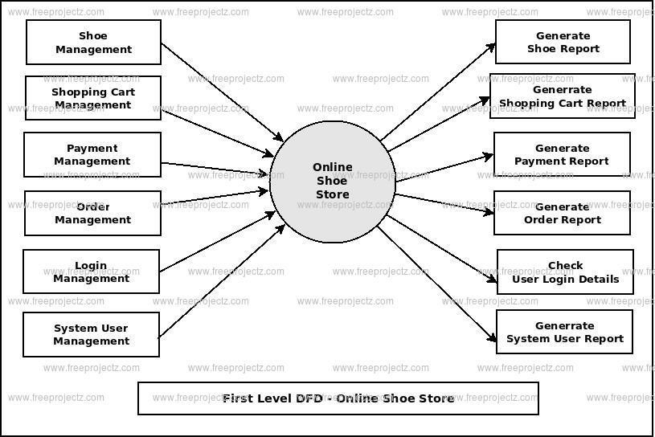

* 1. **DFD 2 LEVEL DIAGRAM**

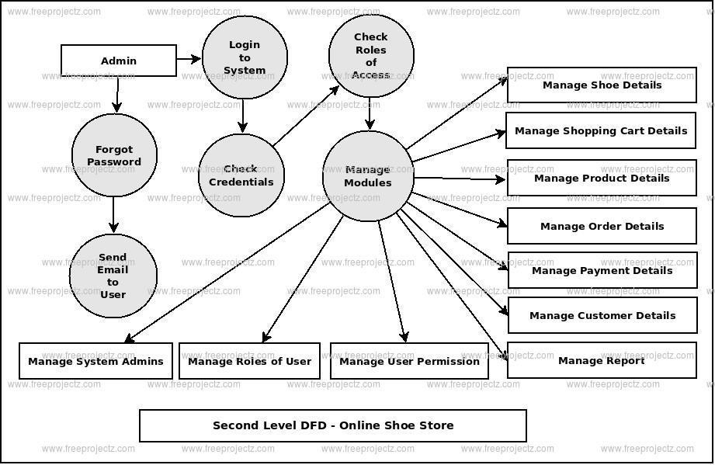

* 1. **USE CASE DIAGRAM**

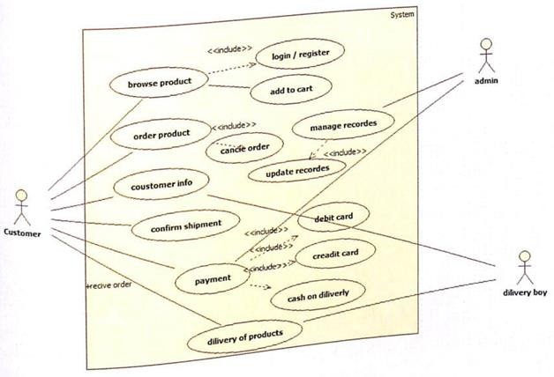

* 1. **CLASS DIAGRAM**

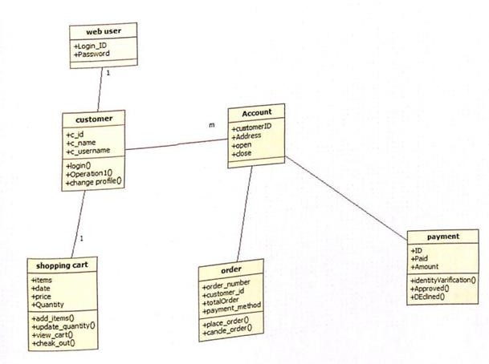

* 1. **DEPLOYMENT DIAGRAM**

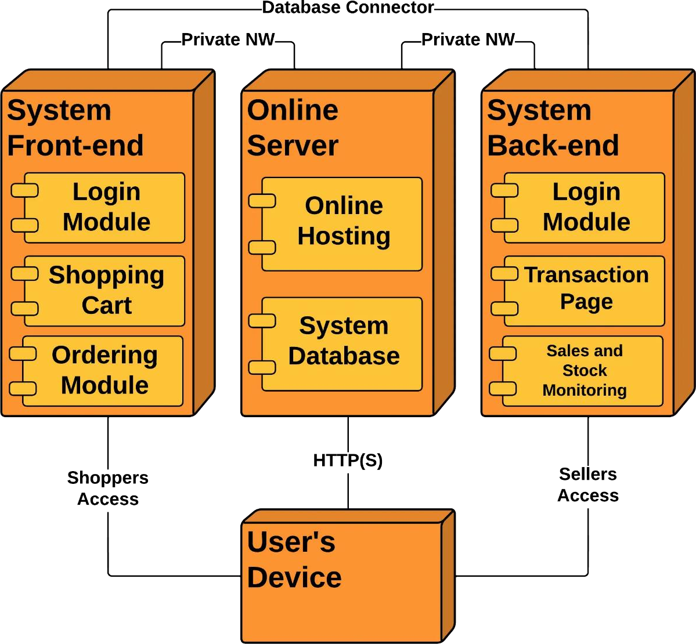

**GUI:**

**Module Screenshot**

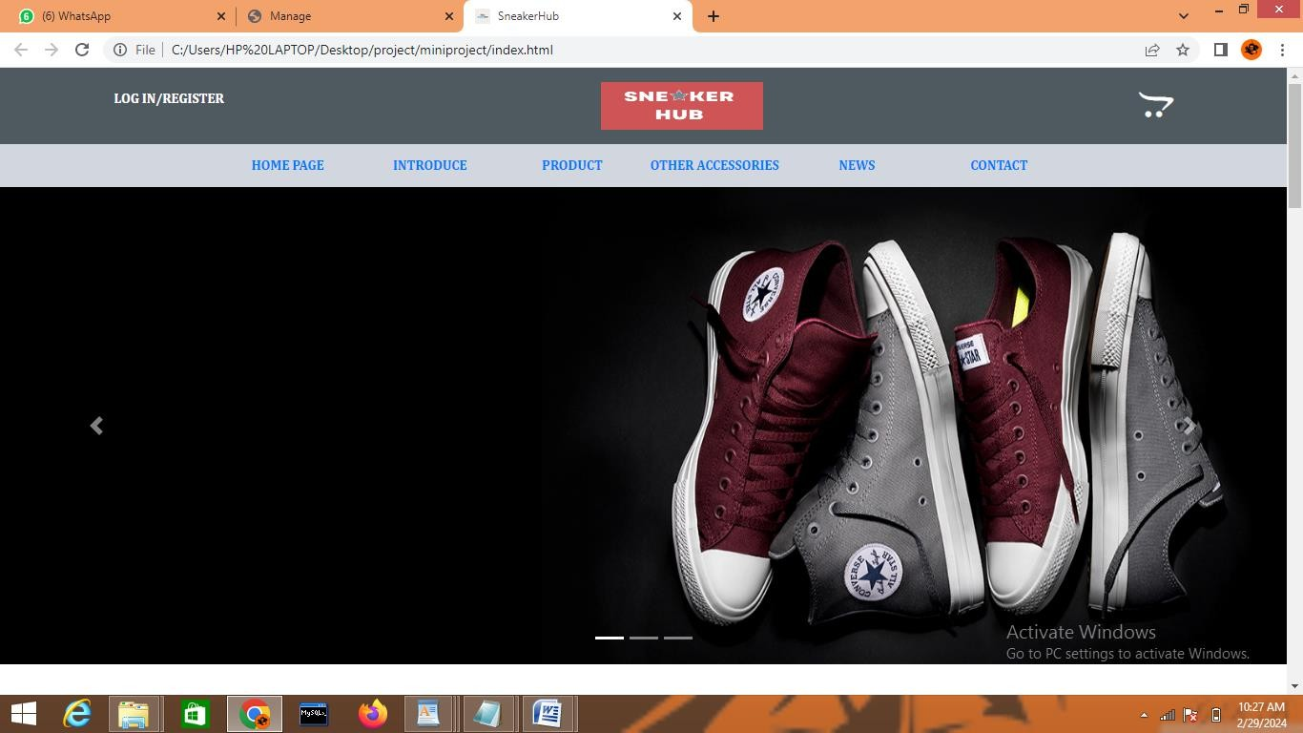

**LOGIN AND REGISTER PAGE**

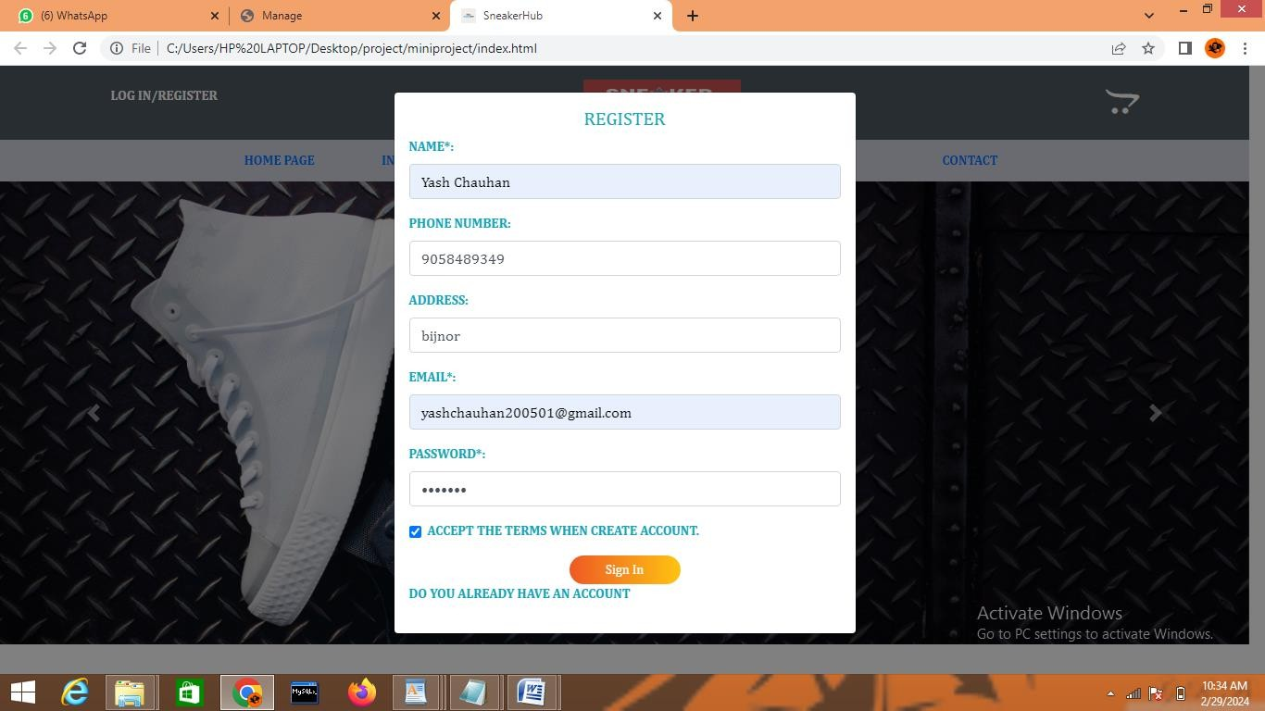

**LOGIN AND REGISTER PAGE**

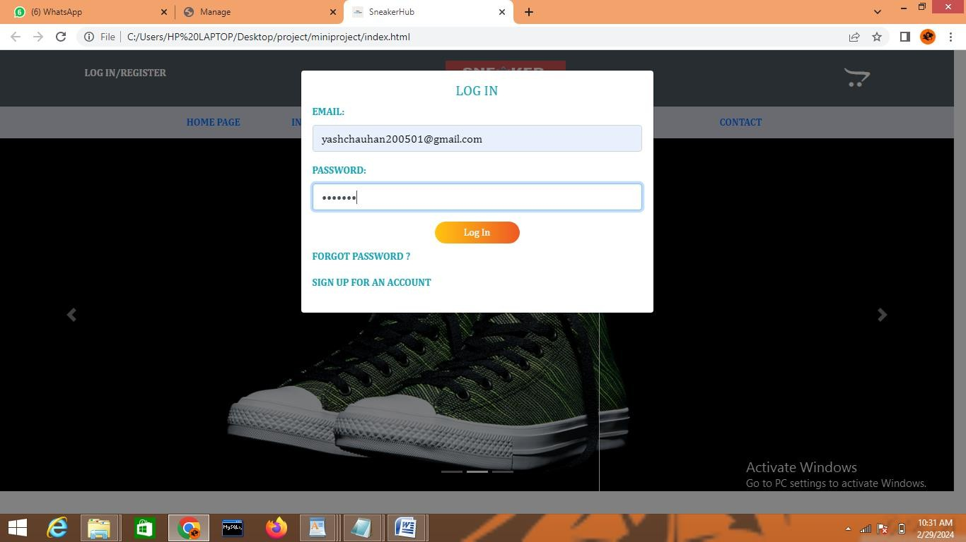

**ACCOUNT INFORMATION**

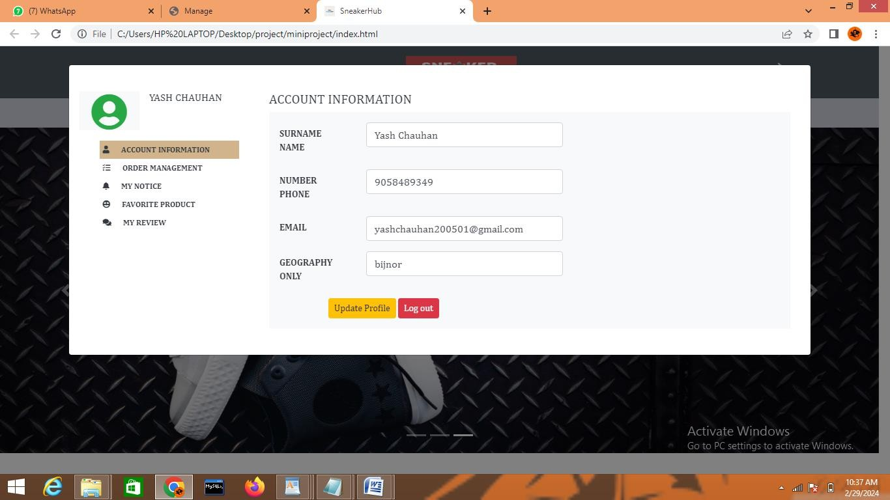

ORDER PRODUCT

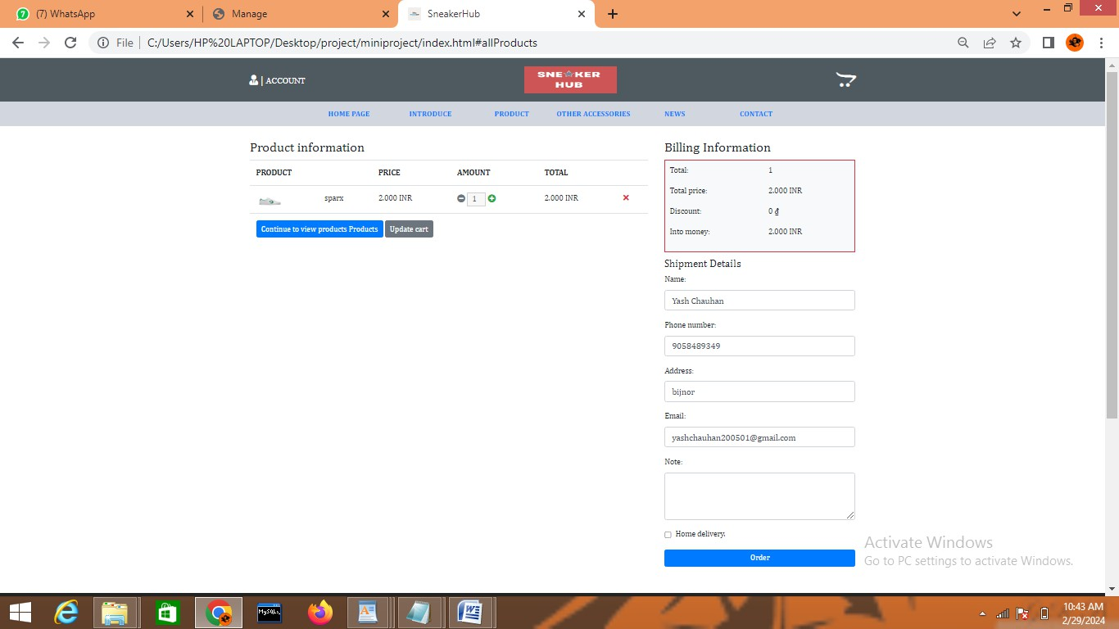

**MY ORDER**

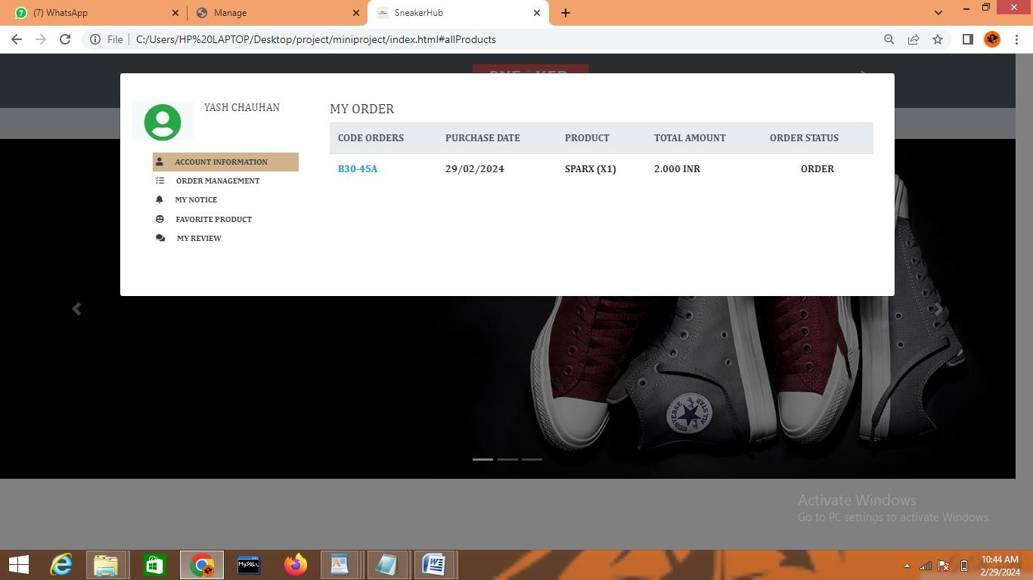

**MANAGE PRODUCT/ADD PRODUCT**

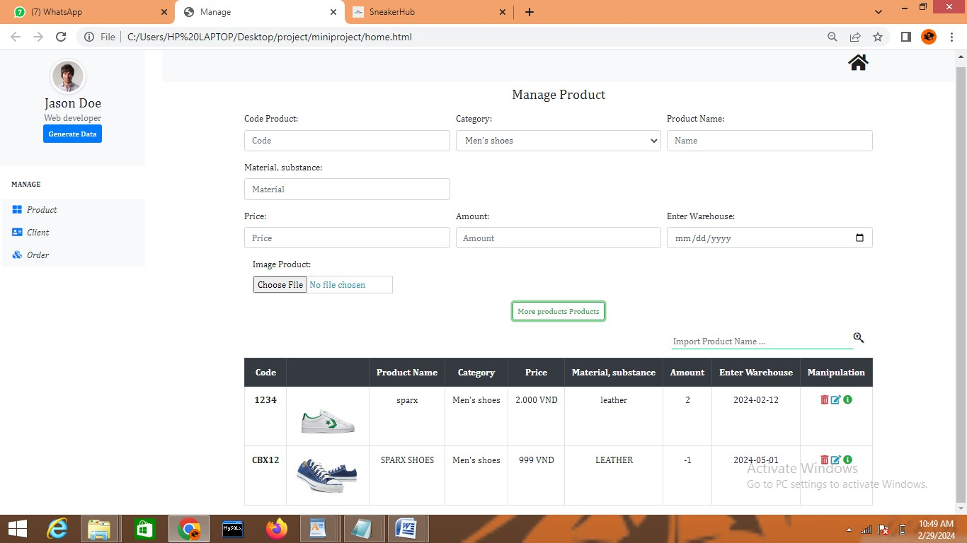

1. **CODING PHASE**

Html Code

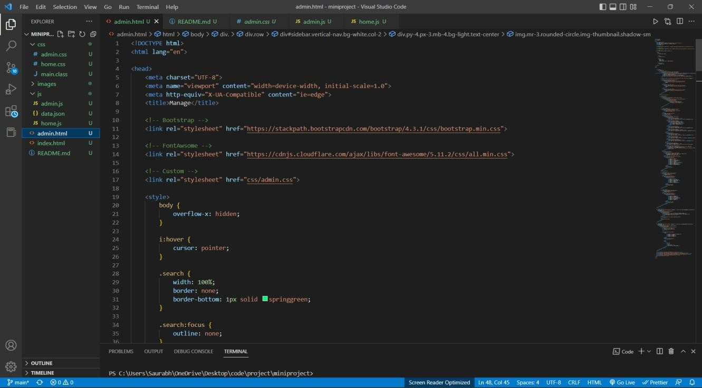

## Home.CSS

{

margin: 0;

padding: 0;

box-sizing: border-box;

}

a:hover {

text-decoration: none;

}

.card {

border: none;

}

body {

font-family: Cambria, sans-serif;

}

/============================ [Header] ============================/

header {

background-color: #D2D6DF; text-transform: uppercase; font-weight: 600;

font-size: 14px;

}

/* header-top */

.header-top {

background-color: #4f5a60; color: white;

}

.header-top .bar-inner { display: flex;

height: 80px;

justify-content: space-between; align-items: center;

}

.header-top .bar-inner .acount-item {

display: flex; cursor: pointer;

}

.header-top .bar-inner .bar-action { display: flex;

}

.header-top .bar-inner .bar-action .cart { position: relative;

cursor: pointer;

}

.header-top .bar-inner .bar-action .cart .cart-quantity { position: absolute;

width: 20px; height: 20px;

background-color: crimson; border-radius: 50%;

text-align: center; top: -8px;

right: -2px;

}

.header-top .bar-inner .bar-action .cart-overlay { position: fixed; /* Sit on top of the page content */ width: 100%; /* Full width (cover the whole page) */ height: 100%; /* Full height (cover the whole page) */

display: none;

top: 0;

left: 0;

right: 0;

bottom: 0;

background-color: rgba(221, 208, 208, 0.5); /* Black background with opacity */

z-index: 2; /* Specify a stack order in case you're using a different order for other elements */

}

.header-top .bar-inner .bar-action .cart-overlay .cart-content { background-color: white;

height: 100%;

}

.header-top .bar-inner .bar-action .cart-overlay .cart-content img { width: 90px;

height: 50px;

}

.header-top .bar-inner .logo img { width: 170px;

height: 50px;

}

.profileToggle { position: relative; display: none;

}

.profileToggle p {

font-size: 12px;

}

.profileToggle .profileAction { position: absolute;

left: 50px; z-index: 1;

width: 500px;

}

.wrapper-form button { border-radius: 30px; width: 120px; outline: none;

background-image: linear-gradient(to left ,#FFC312,#EE5A24,#FFC312); background-size: 200%;

color: #fff;

transition: 0.4s linear;

}

.wrapper-form button:hover { color: #fff;

background-position: right;

}

/* header-bottom */

.header-bottom {

height: 45px;

}

.header-bottom .menu-inner { width: 100%;

height: 100%;

/* background-color: violet; */

}

.header-bottom .menu-inner .menu-bar { width: 80%;

height: 100%;

/* background-color: turquoise; */ margin: auto;

}

.header-bottom .menu-bar ul { width: 100%;

height: 100%; display: flex;

justify-content: space-between; align-items: center;

}

.header-bottom .menu-bar ul li { height: 100%;

width: 16%;

text-align: center; line-height: 45px;

list-style-type: none;

}

.header-bottom .menu-bar ul li:hover { border-bottom: 3px solid brown;

}

.header-bottom .menu-bar ul li a:hover { text-decoration: none;

}

/==================================================================/

.clearfix { width: 100%; height: 100px;

}

/========================= [Banner Product] =======================/

.banner-content .banner-card { box-sizing: border-box; position: relative;

}

.banner-content .banner-card:hover { cursor: pointer;

border: 1px solid black;

}

.banner-content .banner-card:hover .btn-overlay{

-webkit-transform: scale(1);

-ms-transform: scale(1); transform: scale(1);

}

.banner-content .banner-card .btn-overlay { position: absolute;

top: 0;

left: 0;

right: 0; overflow: hidden;

/* background-color: #008CBA; */ width: 100%;

height: 100%; display: flex;

justify-content: center; align-items: center;

-webkit-transform: scale(0);

-ms-transform: scale(0); transform: scale(0);

-webkit-transition: .3s ease; transition: .3s ease;

}

/======================= [Section Product] =====================/

.tabbed-content {

width: 100%; height: 50px;

border-bottom: seagreen 1px solid;

}

.tabbed-content ul { height: 100%;

list-style-type: none; display: flex;

justify-content: center; align-self: center;

}

.tabbed-content ul li { width: 200px; height: 100%;

text-align: center; line-height: 50px; cursor: pointer;

}

.tabbed-content ul li:hover { background-color: salmon; border-bottom: 1px solid red;

}

#extra-product .card:hover {

border: 1px solid red; cursor: pointer;

-webkit-box-shadow: 0 10px 6px -6px #777;

-moz-box-shadow: 0 10px 6px -6px #777;

box-shadow: 0 10px 6px -6px #777;

}

/==================================================================/

/======================= [PR0M0TI0N Product] =====================/

.promotion .promotion-banner { position: relative;

}

.promotion .promotion-banner .promotion-content-banner { position: absolute;

top: 35%;

left: 32%;

}

.promotion .promotion-banner .promotion-content-banner .content-banner { text-align: center;

}

.promotion .promotion-banner .promotion-img-banner { width: 100%;

height: 500px;

background-image: url[("http://mauweb.monamedia.net/converse/wp-](http://mauweb.monamedia.net/converse/wp-) content/uploads/2019/05/banner-1.jpg");

background-repeat: no-repeat; background-attachment: fixed;

background-size: auto;

}

/======================= [ALL Product] =====================/

.all-product .demo-product .one-product { display: flex;

}

.all-product .demo-product .one-product p { margin: 0;

}

.all-product .card .card-title { font-size: 16px;

}

.all-product .card .card-text { font-size: 13px;

}

.all-product .card button { font-size: 12px;

height: 30px;

}

.all-product .card:hover { border: 1px solid red; cursor: pointer;

-webkit-box-shadow: 0 10px 6px -6px #777;

-moz-box-shadow: 0 10px 6px -6px #777;

box-shadow: 0 10px 6px -6px #777;

}

/============================ [Footer] ============================/

footer {

color: #fff;

background-attachment: fixed; background-color:#222;

/* background-image: url(https://s7.postimg.org/uyf0oioaz/footer-bg.png); */ background-size: cover;

background-position: bottom;

}

footer p { color: #ccc;

}

footer a { color: #ccc;

}

.social-pet li a:hover { background-color: #0141a2;

}

.social-pet li a:hover i { transform: rotate(360deg);

-moz-transform: rotate(360deg);

-webkit-transform: rotate(360deg);

}

.recent-post li { display: block; color: #ccc;

margin-bottom: 25px;

}

Body.CSS

body {

font-family: Cambria, sans-serif;

}

.notification { position: relative;

}

.notification .notification-content { display: none;

position: fixed; text-align: center;

background-color: chartreuse;

/* width: 240px; */ height: 40px;

line-height: 40px; z-index: 9999999;

transition: all 2s linear;

color: white;

}

.user-manager { display: none;

}

.order-manager { display: none;

}

/* comment to commit */

**Home/Admin.js**

/ ===================== COMMON DEFINE ====================

// Formatter VND

const formatter = new Intl.NumberFormat('it-IT', { style: 'currency',

currency: 'INR', minimumFractionDigits: 0

})

// Auto Generate ID

function generateUUIDV4() {

return 'xxx-xxy'.replace(/[xy]/g, function (c) {

let r = Math.random() * 16 | 0, v = c == 'x' ? r : (r & 0x3 | 0x8);

return v.toString(16);

});

}

// ==================== DATABASE ==========================

let DATABASE = localStorage.getItem('DATABASE') ? JSON.parse(localStorage.getItem('DATABASE')) : {

PRODUCTS: [], ACCOUNTS: [

// Set User Default role ADMIN

{

ID: generateUUIDV4(), username: "yash_12", phoneNumber: "01672058923", address: "Ghaziabad",

email: ["admin@gmail.com"](mailto:admin@gmail.com), password: "123",

role: "Admin"

}

],

ORDERS: []

};

localStorage.setItem('DATABASE', JSON.stringify(DATABASE));

// Get table to use

let PRODUCTS = DATABASE.PRODUCTS; let ACCOUNTS = DATABASE.ACCOUNTS; let ORDERS = DATABASE.ORDERS;

// ==================== SESSION STORE ==========================

let SESSION = sessionStorage.getItem('SESSION') ? JSON.parse(sessionStorage.getItem('SESSION'))

: null;

// ========================================= CART CLIENT

===========================================

let btn_cart = document.getElementById('btn-cart');

let cart_overlay = document.getElementById('cart-overlay'); let close_cart = document.getElementById('close-cart');

let cart_tbody = document.getElementById('cart-tbody');

// let cart_quantity = document.getElementById('cart-quantity');

btn_cart.addEventListener('click', cartOverlayOn); close_cart.addEventListener('click', cartOverlayOff);

function cartOverlayOn() { cart_overlay.style.display = 'block'; renderCartItems();

}

function cartOverlayOff() {

cart_overlay.style.display = 'none';

}

// Cart Render Items function renderCartItems() {

let checkout = document.getElementById('checkout'); let total_inner = document.getElementById('total'); let products = SESSION.products;

let contents = ''; let total = 0;

if (products === undefined || products.length === 0) {

total_inner.innerHTML = <p class="text-center">There are no products in your shopping cart.</p>;

checkout.style.display = 'none';

} else {

checkout.style.display = 'block'; products.forEach(p => {

contents += `

<tr>

<td>

<img src="images/${p.image}" alt="">

</td>

<td>

<p>${p.productName}</p>

<p>${formatter.format(p.price)}</p>

</td>

<td>

${p.quantity}

</td>

<td>

${formatter.format(p.price * p.quantity)}

</td>

<td>

</td>

</tr>`;

total += (p.price * p.quantity);

})

total_inner.innerHTML = Total Money: ${formatter.format(total)}; cart_tbody.innerHTML = contents;

}

}

// ========================================= FORM ACCOUNT CLIENT

===========================================

let regiseter_form = document.getElementById('regiseter-form'); let login_form = document.getElementById('login-form');

let login_form_area = document.getElementById('login-form-area');

let regiseter_form_area = document.getElementById('regiseter-form-area');

regiseter_form.addEventListener('click', showRegisterForm); login_form.addEventListener('click', showSignForm);

function showRegisterForm() { login_form_area.style.display = 'none'; regiseter_form_area.style.display = 'block';

}

function showSignForm() { login_form_area.style.display = 'block'; regiseter_form_area.style.display = 'none';

}

// ******** REGISTER ACCOUNT ********

// Declare Form Input

let name = document.getElementById('name');

let number = document.getElementById('number'); let address = document.getElementById('address'); let email = document.getElementById('email');

let password = document.getElementById('password');

// let condition = document.getElementById('condition');

let register_btn = document.getElementById('register');

register_btn.addEventListener('click', addNewAccount);

function addNewAccount() { let account = {

ID: generateUUIDV4(), username: name.value, phoneNumber: number.value, address: address.value,

email: email.value, password: password.value, role: "User"

}

if (validateFormRegister()) { ACCOUNTS.push(account);

localStorage.setItem('DATABASE', JSON.stringify(DATABASE)); alert("Create Account Success !");

showSignForm();

}

register_btn.disabled = false;

}

function validateFormRegister() {

let register_input = regiseter_form_area.querySelectorAll('input'); let check = 0;

register_input.forEach(input => { if (input.value === '') {

input.style.border = "1px solid red"; check++;

} else {

input.style.border = "1px solid #ced4da";

}

});

// Stupid again :)) if (check > 0) {

register_btn.disabled = true; return false;

} else {

return true;

}

}

// ******** SIGNIN ACCOUNT ********

let email_login = document.getElementById('email-login');

let password_login = document.getElementById('password-login');

let userAct = document.getElementById('userAct');

let userProfile = document.getElementById('userProfile');

let adminProfile = document.getElementById('adminProfile');

let sign_btn = document.getElementById('signin'); sign_btn.addEventListener('click', actSignIn);

function actSignIn() {

let valueOfAuthen = authenticate(email_login.value, password_login.value); if (valueOfAuthen !== null) {

alert('Logged in successfully !');

sessionStorage.setItem('SESSION', JSON.stringify(valueOfAuthen));

$('#form_account').modal('hide'); checkSession();

} else {

alert('Login failed !');

}

}

// Authenticate Account

function authenticate(email_login, password_login) { let userIDAndRole = null; ACCOUNTS.forEach(account => {

if (account.email === email_login && account.password === password_login) { userIDAndRole = {

userID: account.ID, role: account.role

}

}

});

return userIDAndRole;

}

window.onload = checkSession();

// Check Session Storage function checkSession() {

SESSION = JSON.parse(sessionStorage.getItem('SESSION'));

if (SESSION === null) { userAct.style.display = 'flex'; userProfile.style.display = 'none'; adminProfile.style.display = 'none';

}

}

// ========================================= PROFILE ACCOUNT CLIENT

===========================================

userProfile.addEventListener('click', actProfileToggle); adminProfile.addEventListener('click', actProfileToggle);

let logout = document.getElementById('logout');

logout.addEventListener('click', function () { sessionStorage.clear();

location.reload();

})

function actProfileToggle() {

SESSION = JSON.parse(sessionStorage.getItem('SESSION'));

ACCOUNTS.forEach(function (account) { if (account.ID === SESSION.userID) {

renderProfileDetail(account); renderProfileOrder(account.ID);

}

})

}

function renderProfileDetail(account) {

let p_name = document.getElementById('p_name');

let p_number = document.getElementById('p_number'); let p_email = document.getElementById('p_email');

let p_address = document.getElementById('p_address');

let p_nameTitle = document.getElementById('p_nameTitle');

p_nameTitle.innerText = account.username; p_name.value = account.username;

p_number.value = account.phoneNumber; p_email.value = account.email; p_address.value = account.address;

let manager = document.getElementById('manager'); if (account.role === "Admin") {

manager.style.display = 'block';

} else {

manager.style.display = 'none';

}

// * Update User Pr0fi|e *

let updateProfile = document.getElementById('updateProfile'); updateProfile.addEventListener('click', updateUserProfile);

function updateUserProfile() { account.username = p_name.value; account.phoneNumber = p_number.value; account.email = p_email.value; account.address = p_address.value;

localStorage.setItem('DATABASE', JSON.stringify(DATABASE)); alert('Update Successful !');

}

}

function renderProfileOrder(ID) {

let profileTbody = document.getElementById('profileTbody'); let content = '';

ORDERS.forEach(order => { if (order.userID === ID) {

let productList = ``; let total_price = 0;

order.products.forEach(p => { productList += `

${p.productName} (x${p.quantity})<br>

`

total_price += p.quantity * p.price

});

content += `

<tr>

<th scope="row" class="text-info">${order.orderId}</th>

<td>${order.createDate}</td>

<td>${productList}</td>

<td>${formatter.format(total_price)}</td>

<td class="text-center">${order.status}</td>

</tr>

`;

}

})

profileTbody.innerHTML = content;

}

// ******** Show Profile ***********

let s_profileInfo = document.getElementById('s_profileInfo');

let s_profileOrder = document.getElementById('s_profileOrder');

s_profileInfo.addEventListener('click', showProfileInfo); s_profileOrder.addEventListener('click', showProfileOrder);

function showProfileInfo() {

document.getElementById('account-info').style.display = 'block'; document.getElementById('order-info').style.display = 'none';

}

function showProfileOrder() {

document.getElementById('account-info').style.display = 'none'; document.getElementById('order-info').style.display = 'block';

}

// ========================================= PRODUCT CLIENT

===========================================

let owl_slide = document.getElementById('owl-slide');

let extra_product = document.getElementById('extra-product'); let all_product = document.getElementById('all-product');

window.onload = loadProduct(PRODUCTS);

function loadProduct(PRODUCTS) { PRODUCTS.forEach(product => { if (product.idcategory === "2") {

renderExtraProduct(product);

} else {

renderProduct(product);

}

renderAllProduct(product);

});

let owl = $('.owl-carousel'); owl.owlCarousel({

items: 4, loop: true, margin: 10,

autoplay: true, autoplayTimeout: 1500, autoplayHoverPause: true

});

}

function renderProduct(product) {

let contents = `

<div class="card" style="width: 18rem;" data-aos="fade-left">

<img src="images/${product.image}" class="card-img-top" alt="">

<div class="card-body">

<h5 class="card-title">${product.productName}</h5>

<p class="card-text">${formatter.format(product.price)}</p>

<button class="btn btn-primary btn-sm" id="addCart" data-code="${product.code}">Add To Cart</button>

</div>

</div>`;

owl_slide.innerHTML += contents;

}

function renderExtraProduct(product) { let contents = `

<div class="card text-center col-3 mb-2" data-aos="zoom-in-down">

<img src="images/${product.image}" class="card-img-top" alt="">

<div class="card-body">

<h5 class="card-title">${product.productName}</h5>

<p class="card-text">${formatter.format(product.price)}</p>

<button class="btn btn-primary btn-sm" id="addCart" data-code="${product.code}">Add To Cart</button>

</div>

</div>`;

extra_product.innerHTML += contents;

}

function renderAllProduct(product) { let contents = `

<div class="card col-3 text-center mb-2" data-aos="zoom-in-right">

<img src="images/${product.image}" class="card-img-top">

<div class="card-body">

<h5 class="card-title">${product.productName}</h5>

<p class="card-text">${formatter.format(product.price)}</p>

<button class="btn btn-primary btn-sm" id="addCart" data-code="${product.code}">Add To Cart</button

if (check === 0) { products.push(product);

}

} else {

SESSION.products = []; SESSION.products.push(product);

}

sessionStorage.setItem('SESSION', JSON.stringify(SESSION)); alert('Add Products To Cart Successfully !');

}

// ******** CART DETAIL ********

let checkout = document.getElementById('checkout');

let body_content = document.getElementById('body-content'); let body_cart = document.getElementById('body-cart');

let cart_table = document.getElementById('cart-table');

checkout.addEventListener('click', showCartDetail);

function showCartDetail() { cartOverlayOff(); body_content.style.display = 'none'; body_cart.style.display = 'block'; renderCartDetail();

}

function renderCartDetail() {

let products = SESSION.products; let contents = '';

let total_price = 0;

let total_quantity = 0;

products.forEach(p => { contents += `

<tr>

<td>

<img width="50" height="25" src="images/${p.image}" alt="">

</td>

<td>${p.productName}</td>

<td>${formatter.format(p.price)}</td>

<td>

<i class="fas fa-minus-circle text-secondary" id="minus" data-code="${p.code}"></i>

<input type="text" value="${p.quantity}" min="1" style="width: 35px; padding-left: 8px;" disabled />

<i class="fas fa-plus-circle text-success" id="plus" data-code="${p.code}"></i>

</td>

<td>${formatter.format(p.price * p.quantity)}</td>

<td>

<i class="fas fa-times text-danger" id="remove" data-code="${p.code}"></i> payMethod: 'Home delivery',

products: SESSION.products,

createDate: moment(new Date()).format("DD/MM/YYYY"), status: 'Order'

}

if (validateForm()) { ORDERS.push(order);

localStorage.setItem('DATABASE', JSON.stringify(DATABASE)); alert('Order successful !');

SESSION.products = [];

sessionStorage.setItem('SESSION', JSON.stringify(SESSION));

location.reload();

}

order_btn.disabled = false;

}

function validateForm() {

let customer_form = document.getElementById('customer-form'); let customer_input = customer_form.querySelectorAll('input');

let check = 0; customer_input.forEach(input => {

if (input.value === '') { input.style.border = "1px solid red"; check++;

} else {

input.style.border = "1px solid #ced4da";

}

})

// Stupid again :)) if (check > 0) {

order_btn.disabled = true; return false;

} else {return true;

## Timeline of the project:

|  |  |
| --- | --- |
| **Project Life cycle** | **Timeline** |
| **Initiating/Defining** | Completed |
| **Planning/Designing** | Completed |
| **Executing/Coding** | Completed |
| **Clo** | Processing |

1. **Gantt Chart:**

|  |  |  |  |  |
| --- | --- | --- | --- | --- |
|  | Week1 | Week2 | Week3 | Week4 |
| Phase 1 | **Initiating** | **Planning** | **Defining** | **Need** |
| Phase 2 | **Requirement** | **Blue Print** | **Designing** | **Building** |
| Phase 3 | **Front end** | **Development** | **Back end** | **Development** |
| Phase 4 | **Testing** | **Validating** | **Verifying** | **Deploying** |

1. **Benefits of Sneaker Hub:**

Asneakerhubwebsiteoffersseveralbenefitsforsneakerenthusiastsandcollectors:

1. **WideSelection:**Thesewebsitesoftenhaveavastinventoryofsneakers,includingrare and limitededition releases, allowing customers to find the exact pair they desire.
2. Shoppingforsneakersonlineisconvenientasitallowscustomersto browse and purchase from the comfort of their own homes, eliminating the need to visit multiple stores.
3. Sneakerhubwebsitessometimescollaboratewithbrandsorhave

exclusivepartnerships,offeringcustomersaccesstoreleasestheycan'tfindelsewhere.

**ExclusiveReleases:**

**Convenience:**

1. **Scope for the project Sneaker Hub:**

Thescopeofasneakerhubcanbequitebroad,encompassingvariousaspectsrelatedtosneakersandsneakerculture.Herearesomekeyareaswithinthescopeofasneakerhub:

1. **E-Commerce Platform:**The primary function of a sneaker hub is often as an e- commerceplatformwhereuserscanbrowse,purchase,andsometimessellsneakers. Thisincludesprovidingauser-friendlyinterface,securepaymentoptions,andefficient order processing and shipping.
2. A successful sneaker hub fosters a vibrant community ofsneakerenthusiasts.Thiscaninvolveforums,socialmediaintegration,liveevents,andotherinteractivefeatureswhereuserscanconnect,sharetheirpassionforsneakers, discussreleases,andshowcasetheircollections

**CommunityEngagement:**

1. **CONCLUSION**

Automation of the whole system improves the performance of the project and it provides a user-friendly graphical interface which proves to be better when compared to the existing system. It also gives applicable access to the authorized users depending on their authorizations.

The central concept of the application is to allow the customer to shop virtually using the Internet and allow customers to buy the shoes online so that they can purchase the shoes online.

The records affecting to the products are stores on an RDBMS at the server side The Server process the customers and the items are add to the address submitted by them. The application which is deployed at the customer database, the details of the items are brought forward from the database for the customer view based on the selection through the menu and the database of all the products are updated after each transaction. System security, data security and reliability are the conspicuous features. The System has adequate scope for modification in future if it is necessary so we can improve the features of the project

1. **REFERENCES**

### Abukhader, S. M., & Jonson, G. (2004). E-commerce and the environment: A gateway to the renewal of greening supply chains. International Journal of Technology Management,28(2), 274. doi:10.1504/ijtm.2004.005066

* 1. Abukhader, S. M. (2008). Eco-efficiency in the era of electronic commerce – should ‘Eco-Effectiveness’ approach be adopted? Journal of Cleaner Production,16(7), 801- 808. doi:10.1016/j.jclepro.2007.04.00.
  2. Allington, A. (2018, October 05). ‘Over boxing’ Becomes Enemy No. 1 in Amazon- Led Web-Shopping Boom. Retrieved March 22, 2019, from [https://www.bna.com/amazon-](https://www.bna.com/amazon-retailers-redo) [retailers-redo](https://www.bna.com/amazon-retailers-redo)